# CS 5700 -- Computer Security and Information Assurance Fall 2018

Prof. Leszek Lilien / TA: Abduljaleel Al-Hasnawi

Department of Computer Science

Western Michigan University

LAB ASSIGNMENT - 2

NAME: SAMPATH TALLURI

TABLE OF CONTENTS

1. **Introductory Part: Enable Inbound Rules for IPv4 and IPv6 .......................................................................... 3** 
   1. Step 1: Enable Inbound Rules for IPv4 and IPv6 on Win8.1. .......................................................................... 3
   2. Step 2: Enable Inbound Rules for IPv4 and IPv6 on W2K12. ......................................................................... 4
2. **Lab 1.1w: Windows Client Configuration ......................................................................................................... 5** 
   1. Step 1: Start Win8.1 ....................................................................................................................................... 5
   2. Step 2: View and Record the Network Configuration ..................................................................................... 6
   3. Step 3: Change the IP Address of Win8.1 ....................................................................................................... 8
   4. Step 4: Change the IP Address of W2K12 Server. ........................................................................................ 10
   5. Step 5: From Win8.1 Ping the W2K12 Server .............................................................................................. 12
   6. Step 6: View and Modify the ARP Table ...................................................................................................... 13
3. **Lab 1.2w: Name Resolution in Windows ......................................................................................................... 14** 
   1. Step 1: Login to Win8.1 as administrator ...................................................................................................... 14
   2. Step 2: Ping Win8.1 ..................................................................................................................................... 15
   3. Step 3: View and Modify the Host File......................................................................................................... 15
4. **Lab 1.3w: Windows IPv6 Basics ...................................................................................................................... 18** 
   1. Step1: Verify IPv6 Setting for Win8.1 and W2K12 ...................................................................................... 18
   2. Step2: Install Wireshark on Win8.1 .............................................................................................................. 19

**5.Issues……………………………………………………………………………………………………………………………………………21**

**6.Recorded Time………………………………………………………………………………………………………………………………22**

# 1. Introductory Part: Enable Inbound Rules for IPv4 and IPv6

->Step1: Enable Inbound Rules for IPv4 and IPv6 on Win8.1.

**-**Run Windows 8.1 on VM ware, and go to Control Panel ->Windows Firewall to make changes in the advanced settting on the system.

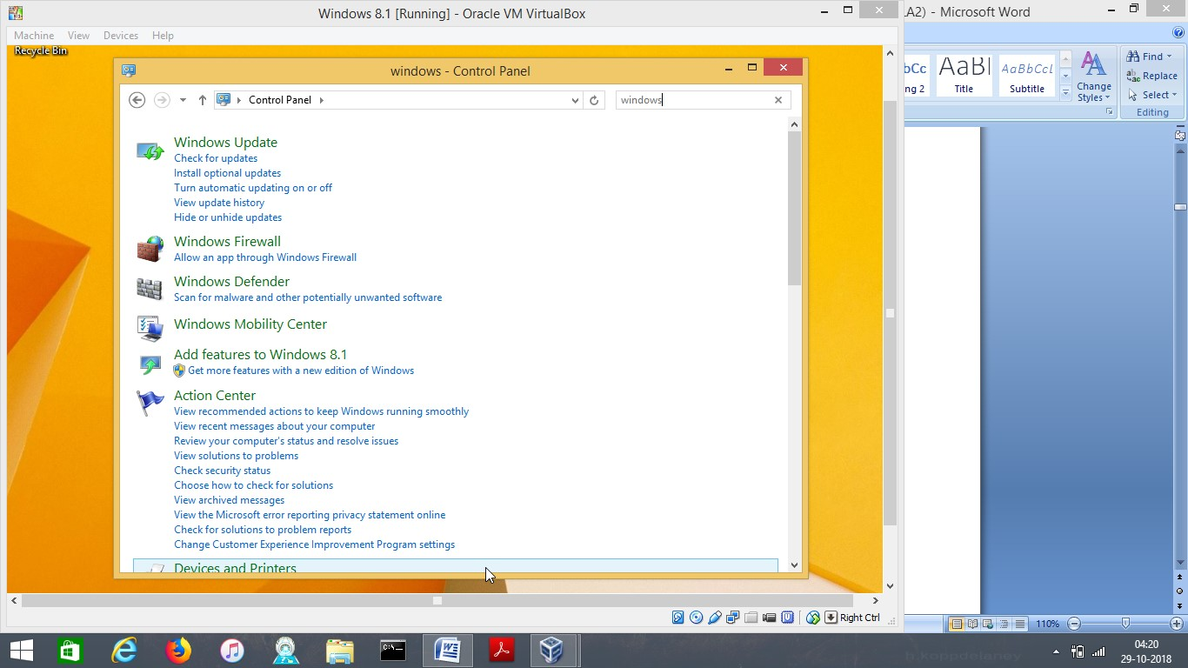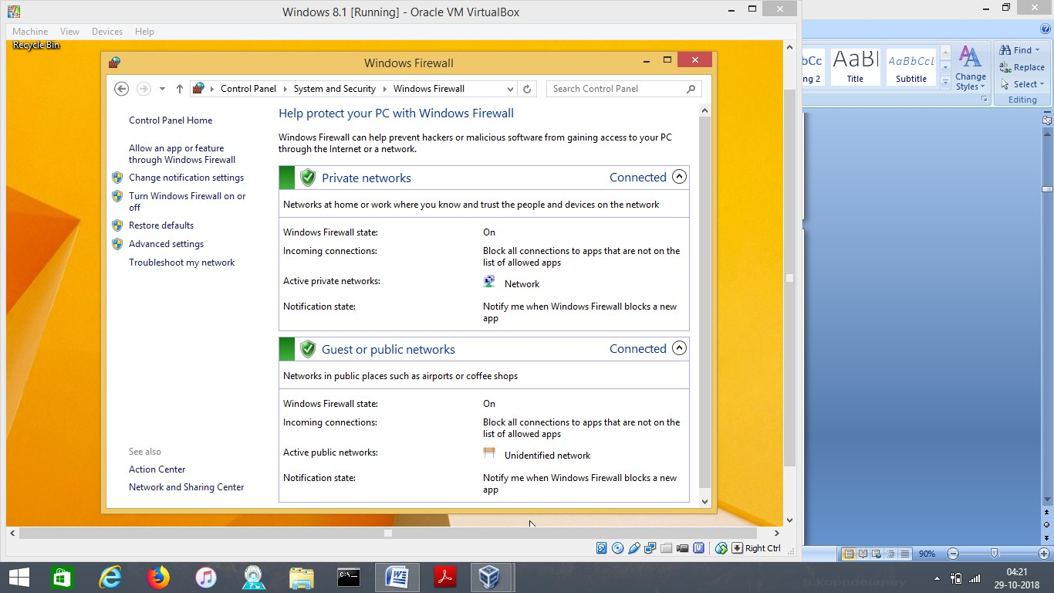

-Go to Advanced setting and select inboundRules, which will display set of settings in which we need to enable the rules for both IPv4 and IPV6 ( File and sharing ) as shown below

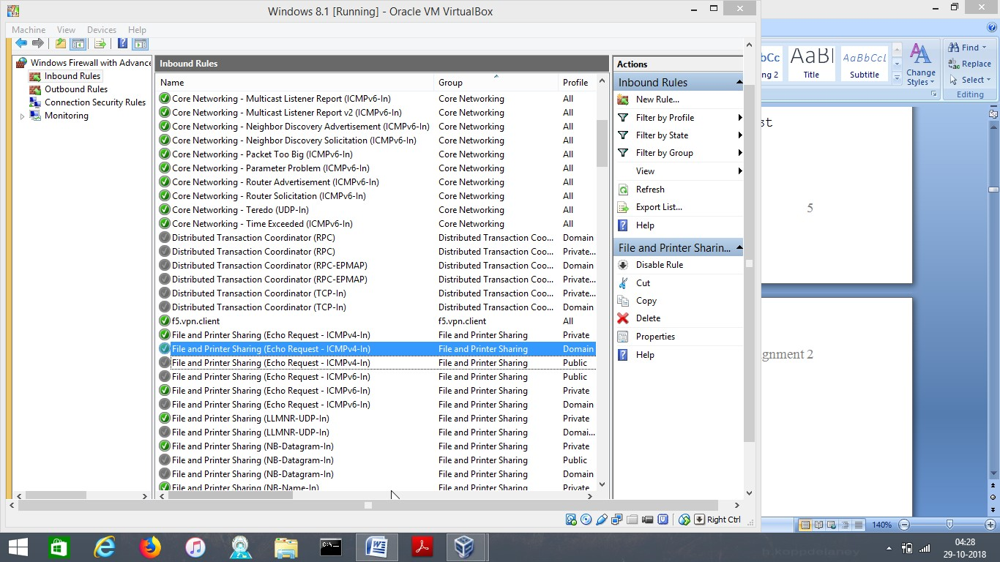

Step2: Enable Inbound Rules for IPv4 and IPv6 on W2K12.

Follow the same steps on Windows Server 2012 to enable the rules.

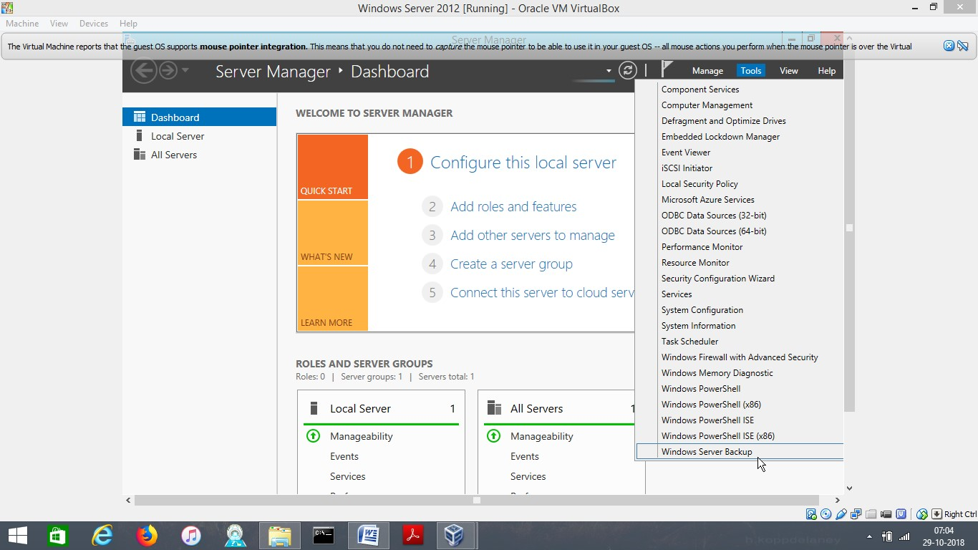

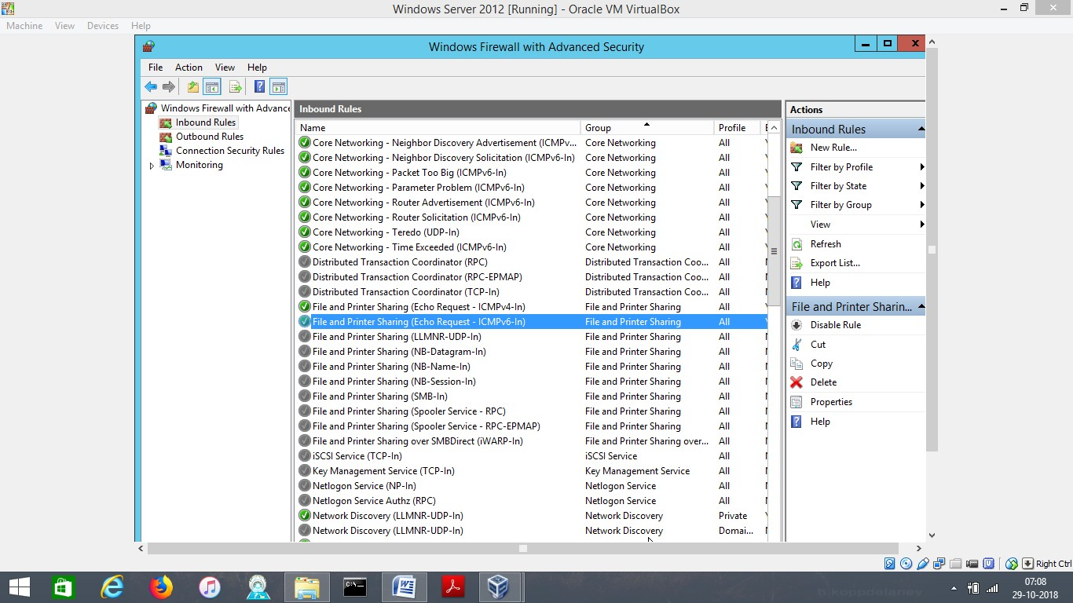

# 2 .Lab 1.1w: Windows Client Configuration

2.1. Step 1: Start Win8.1**.**

Start Windows 8.1.

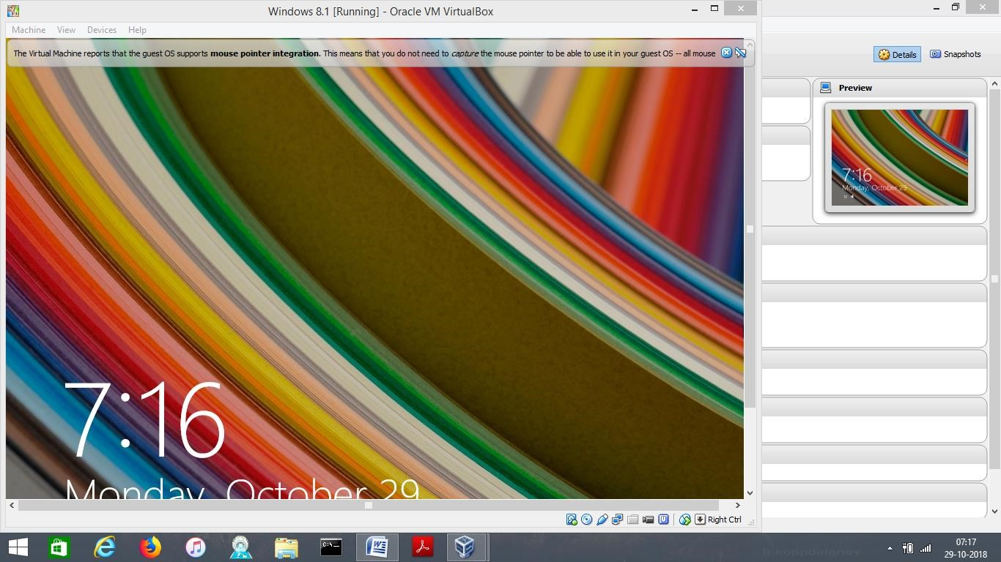

**Step 2: View and Record the Network Configuration.**

On Windows 8.1, open command Prompt and run as administrator as shown below.

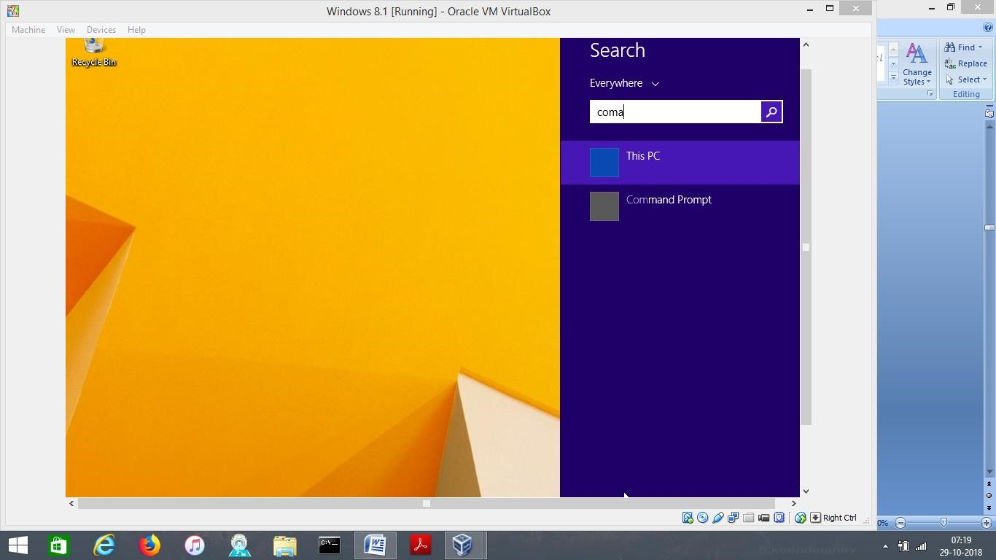

-Type ipcofig /?, which will display you the ip confirguration of the guest system.

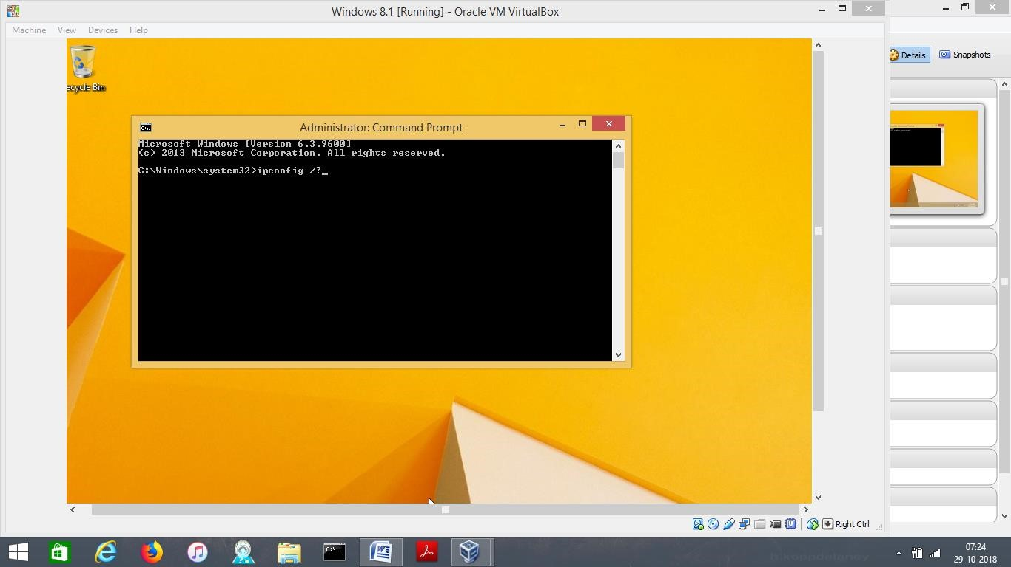

-Type ipconfig /all, which will then show you the overall system configurations, connections (Ethernet Adaptor configurations)

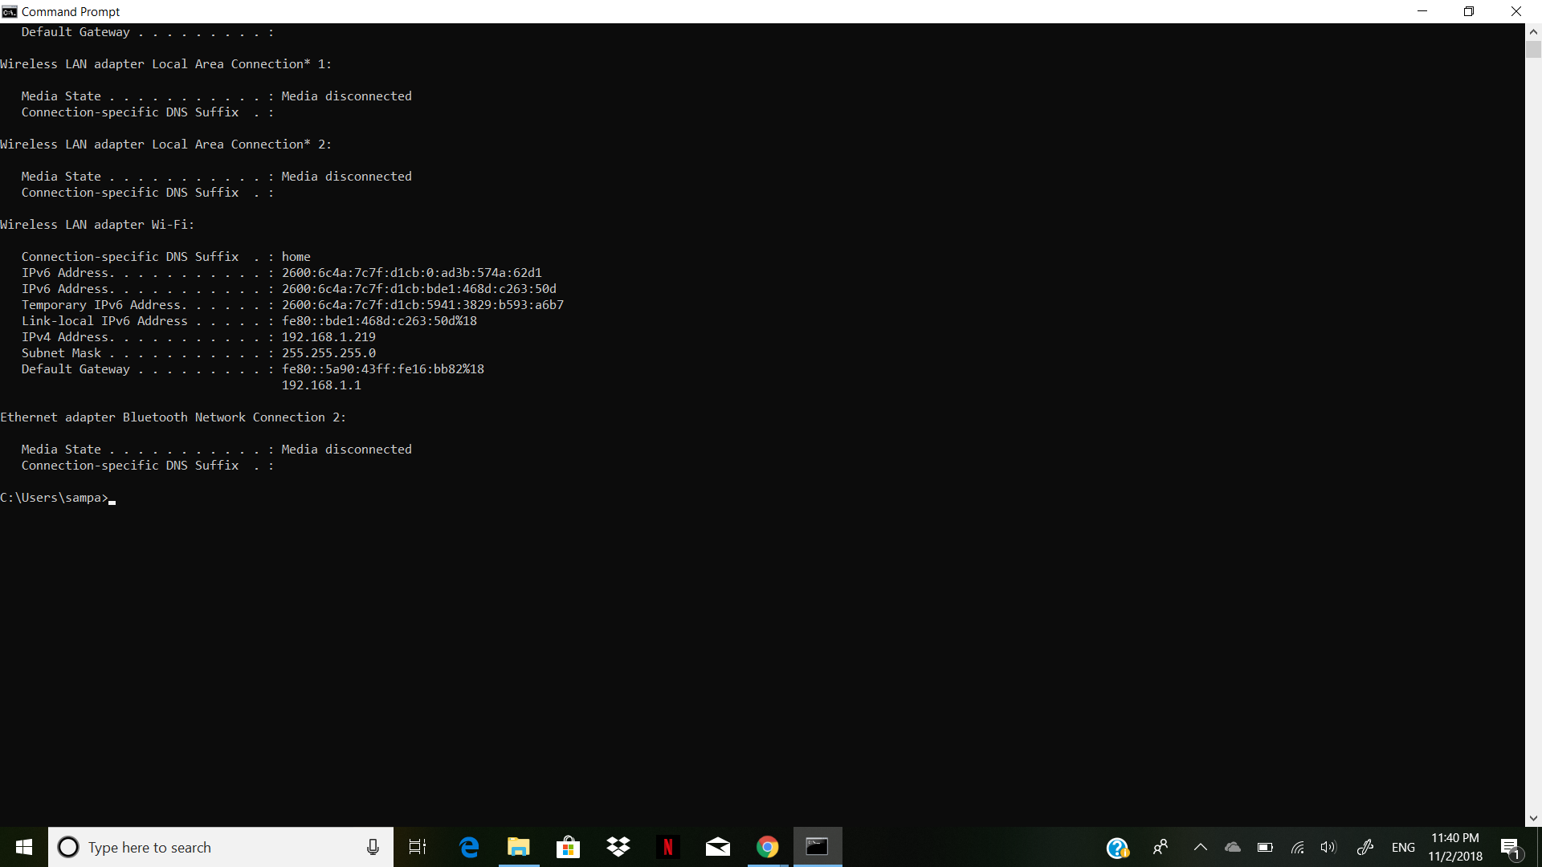

**Step 3: Change the IP Address of Win8.1.**

-On Windows 8.1, Go to Control Panel and then go to Network And Internet.

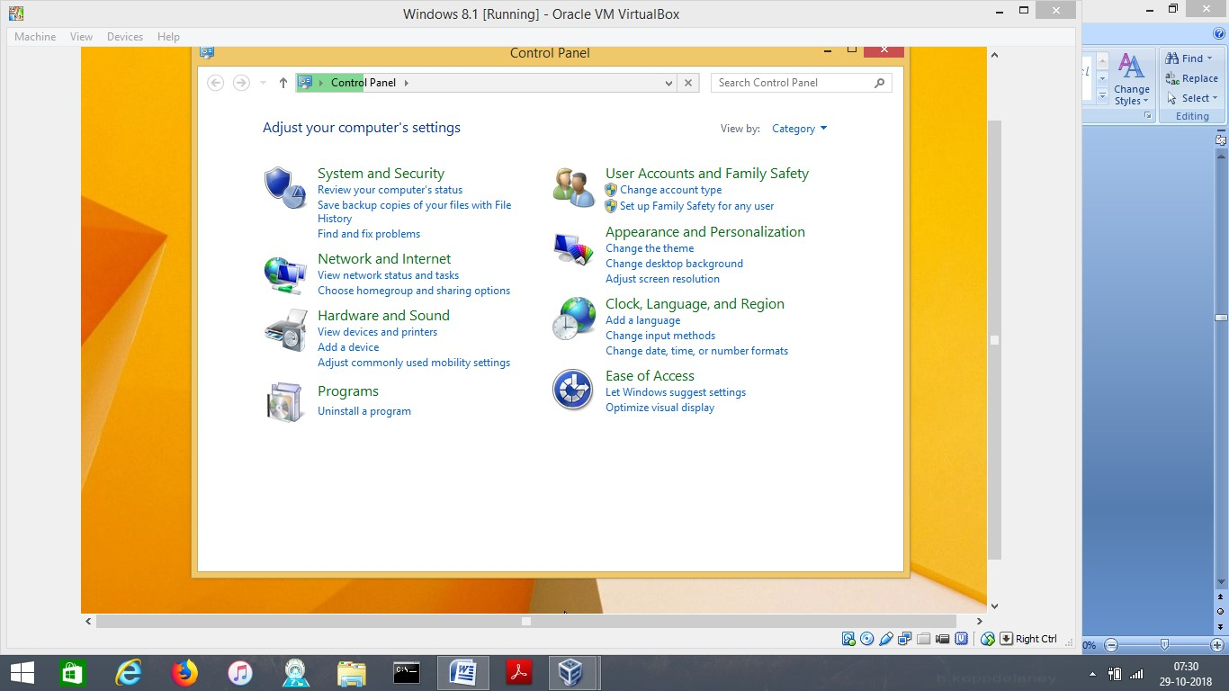

**-**SELECT NETWORK AND SHARING CENTER.

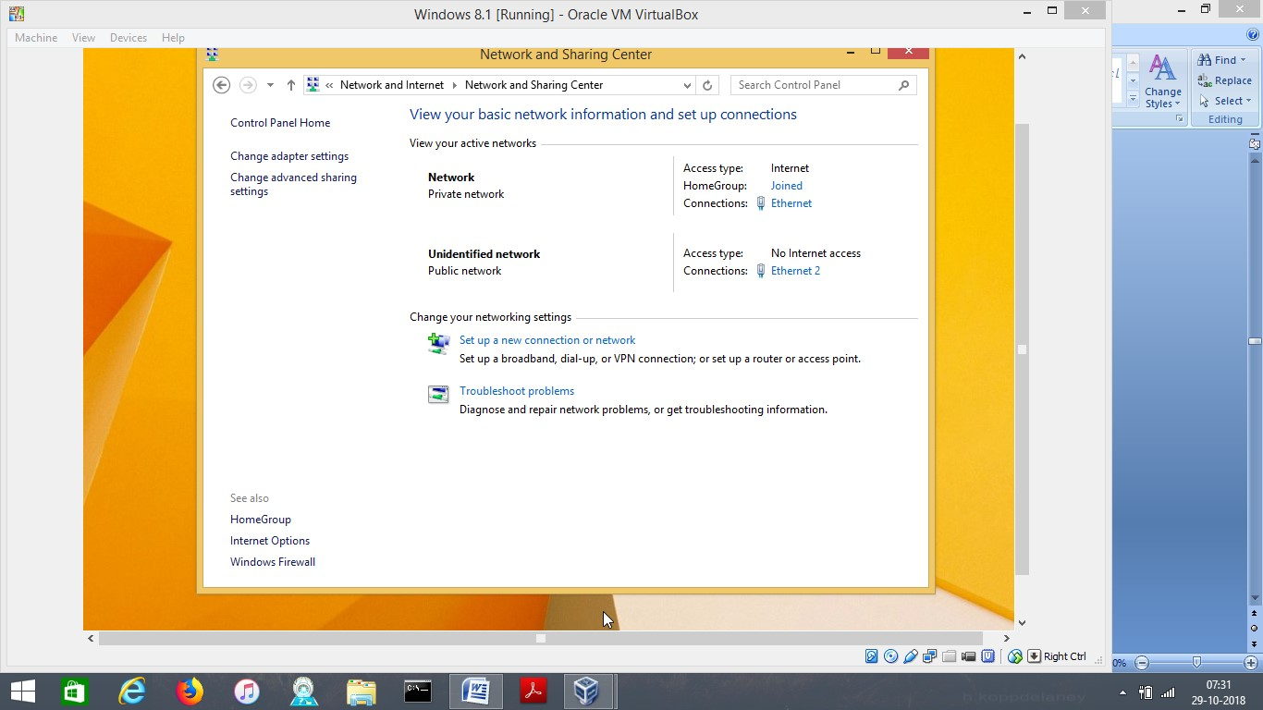

-HERE WE NEED TO GO TO CHANGE ADAPTER SETTINGS. AND GO TO ETHERNET

PROPERTIES TO SELECT (INTERNET PROTOCOL VERSION 4)

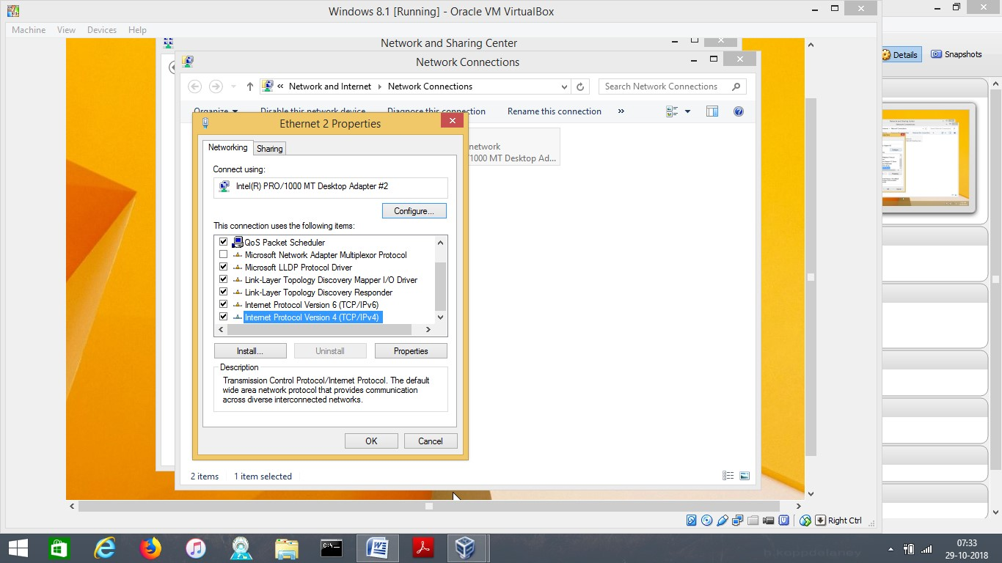

GO TO THE PROPERTY SETTINGS AND CHANGE THE IP ADDRESS AS SHOWN IN THE FIGURE.

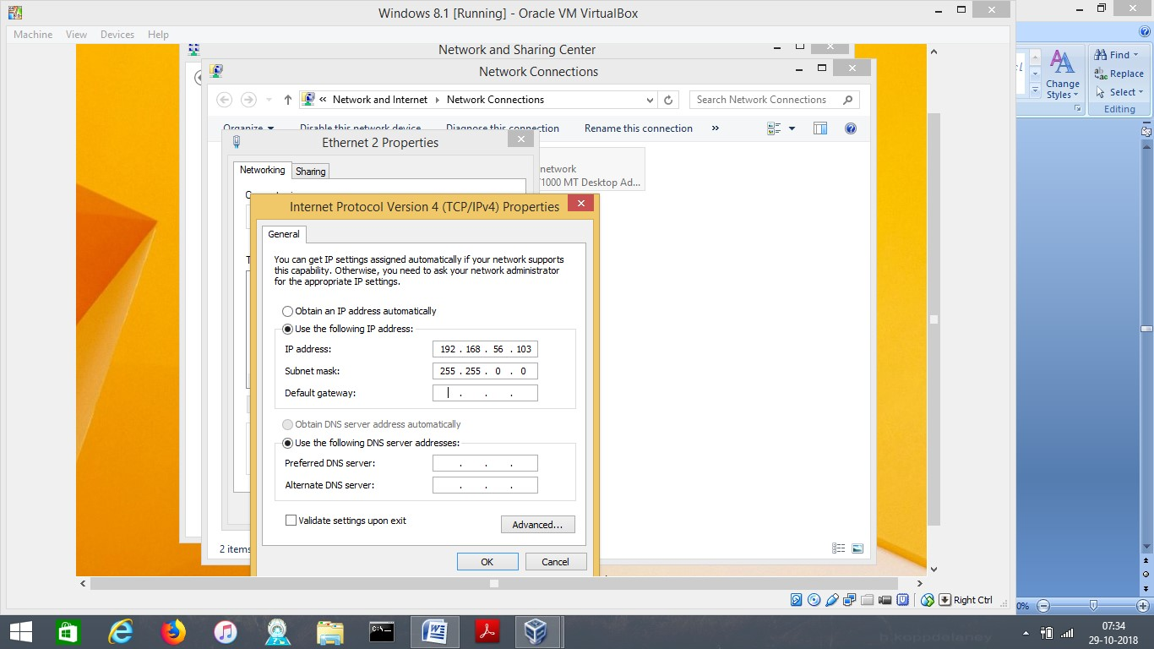

**-**AGAIN GO TO COMMAND PROMPT AND CHECK THE IP CONFIGURATION CHANGE BY TYPING (IPCONFIG)



**Step 4: Change the IP Address of W2K12.**

**-**Follow the same steps and change ip address of W2k12 as shown below.

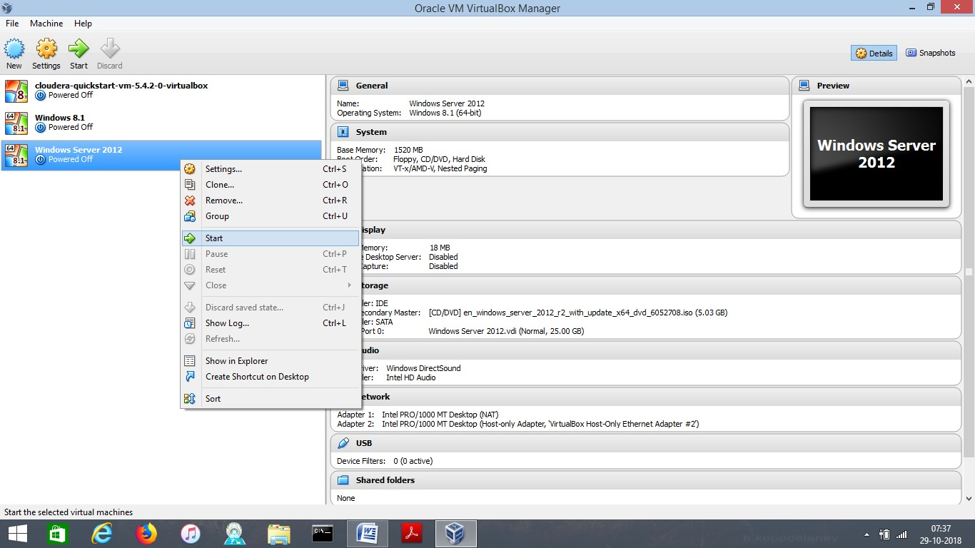

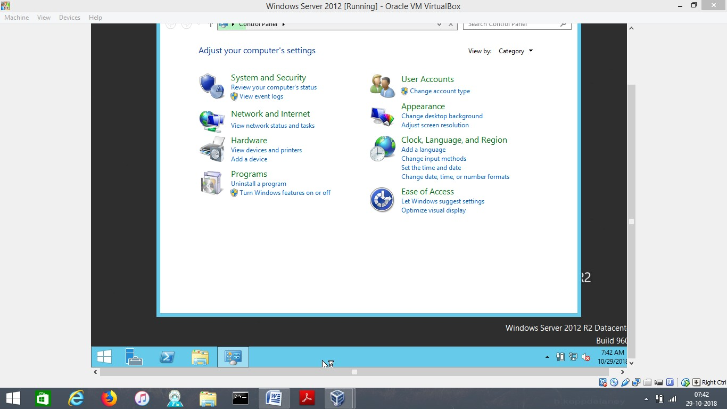

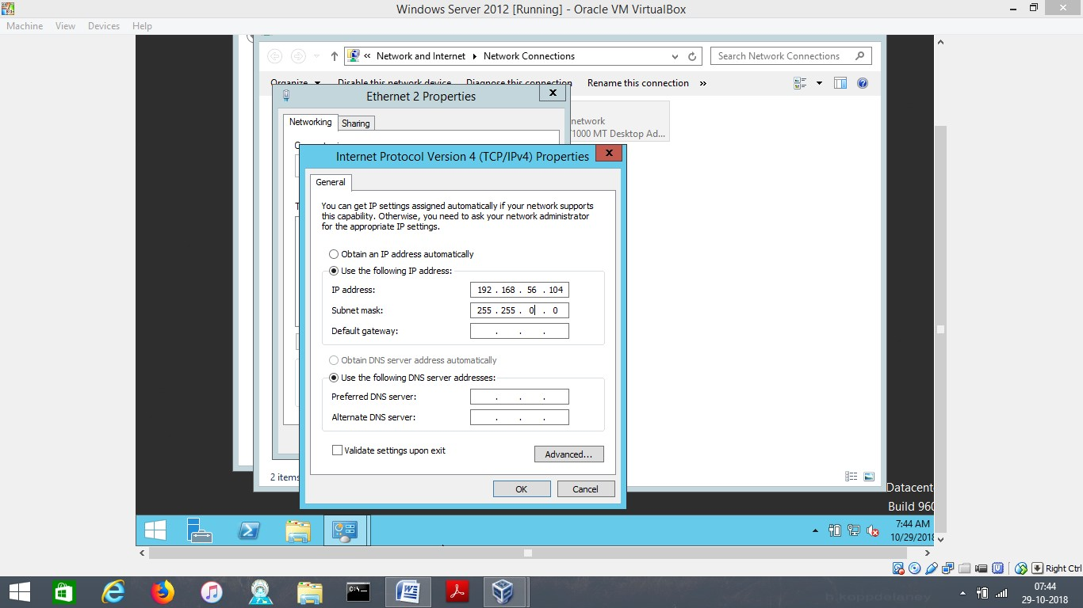

**-**GO TO COMMAND PROMPT TO OBSERVE THE CHANGES MADE IN THE IP ADDRESS BY TYPING ‘IPCONFIG’.

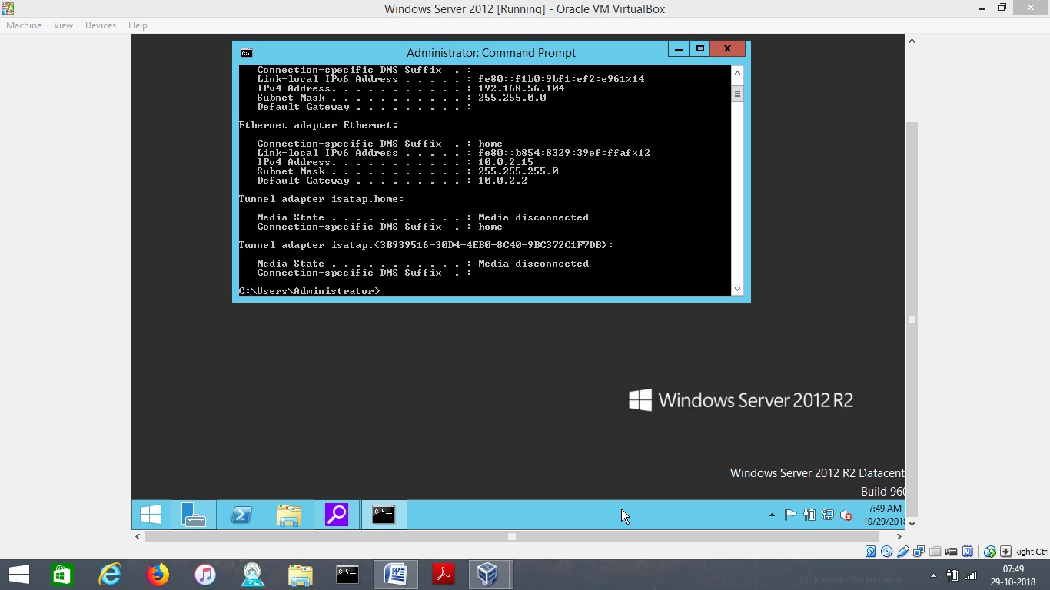

**Step 5: From Win8.1, Ping the W2K12 Server**

In this step we need to ping server w2k12 from 8.1, on windows 8.1 , command prompt type ping 192.168.56.104

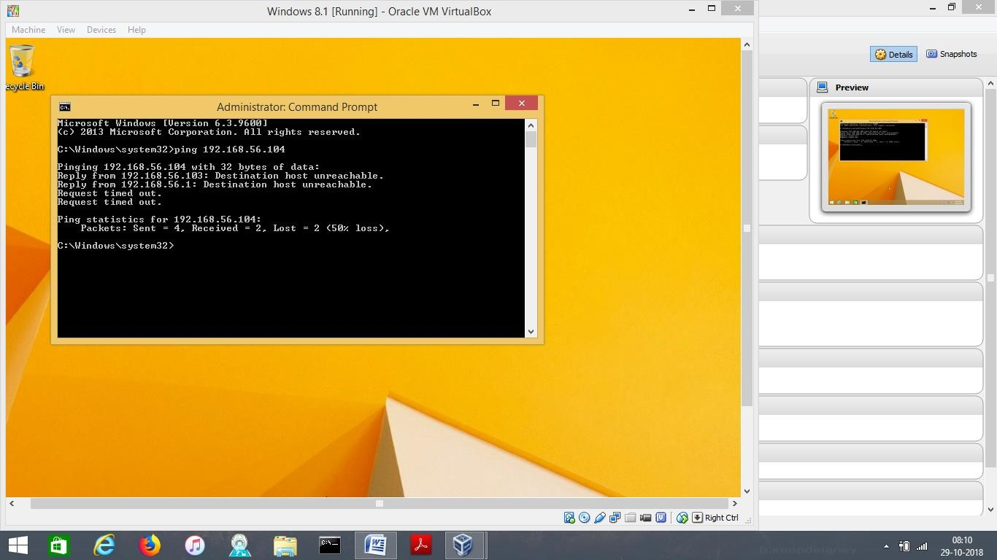

**Step 6: View and Modify the ARP Table.**

-Type arp /?

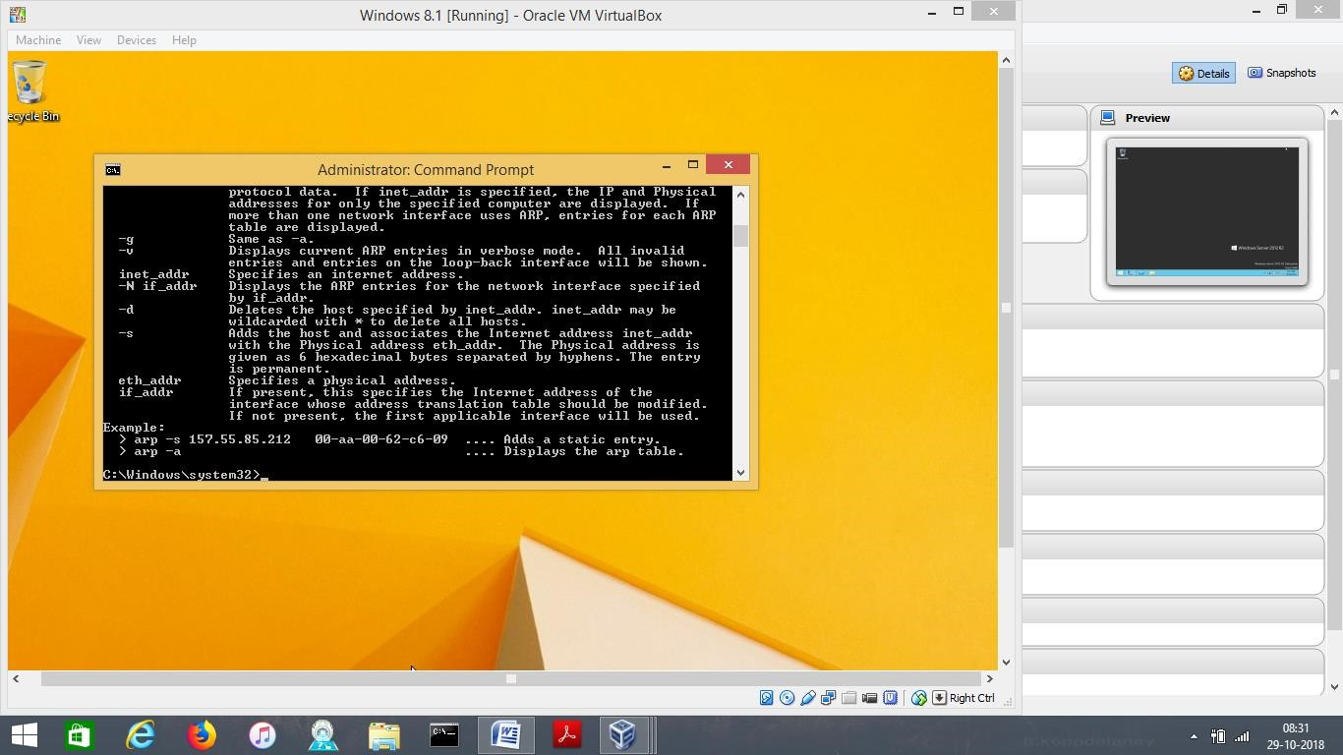

**-**Type arp -a

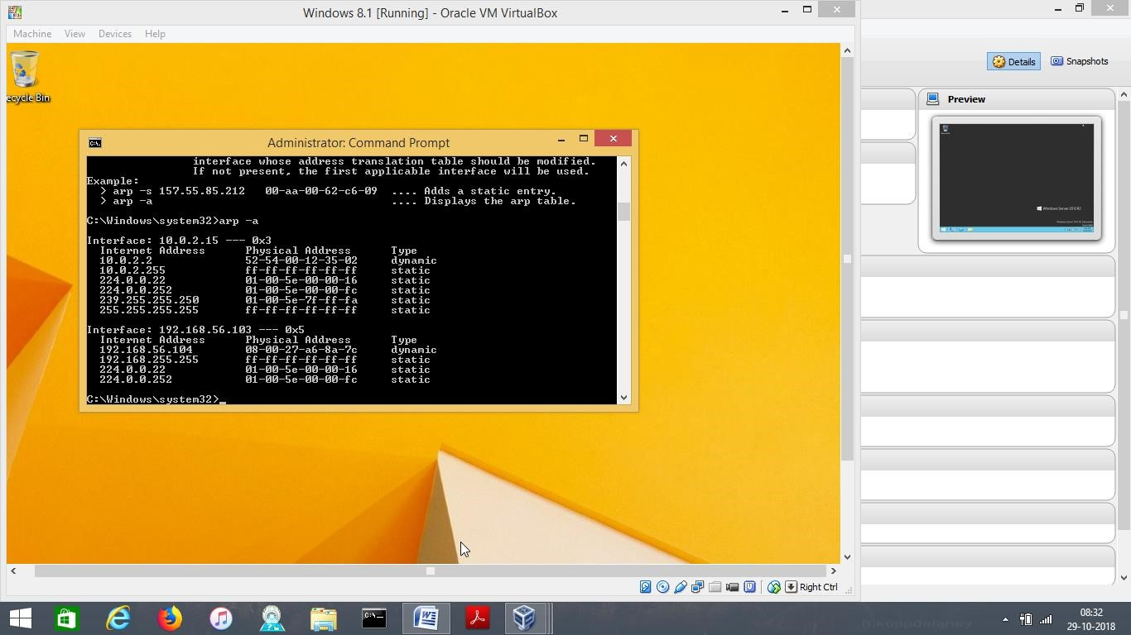

**-**Type arp –d and arp –a, and observe.

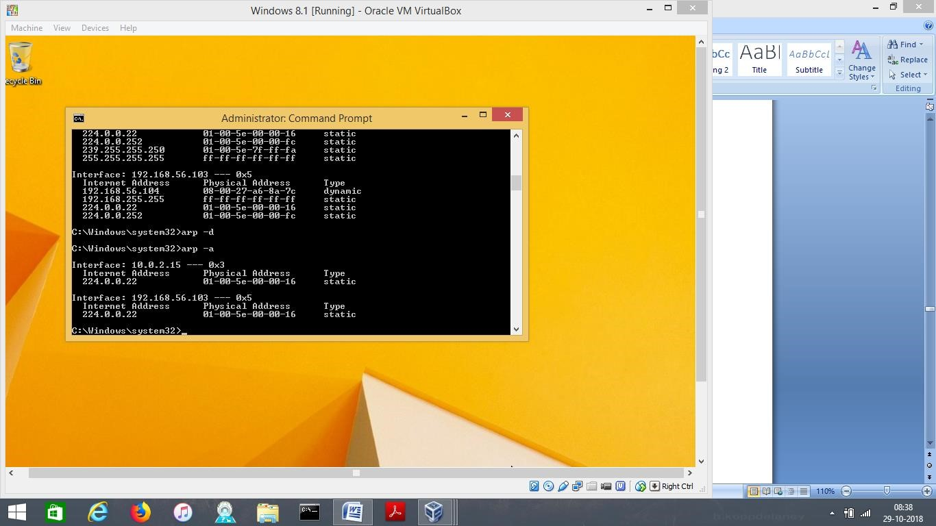

# 3 Lab 1.2w: Name Resolution in Windows

**Step 1: Login to Win8.1 as administrator and ping local host -**ping 127.0.0.1, and you can see the transactions.

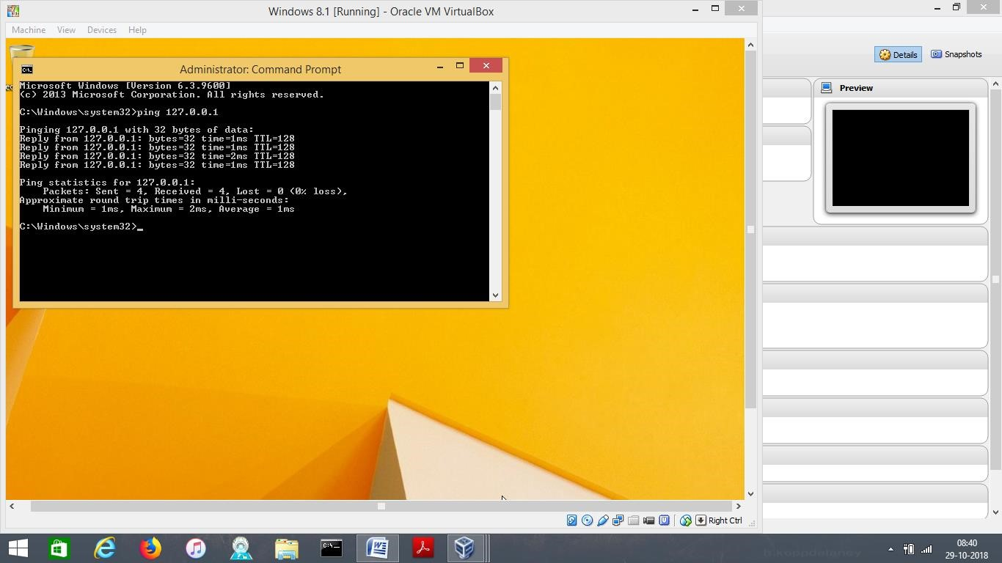

-Type ping localhost.

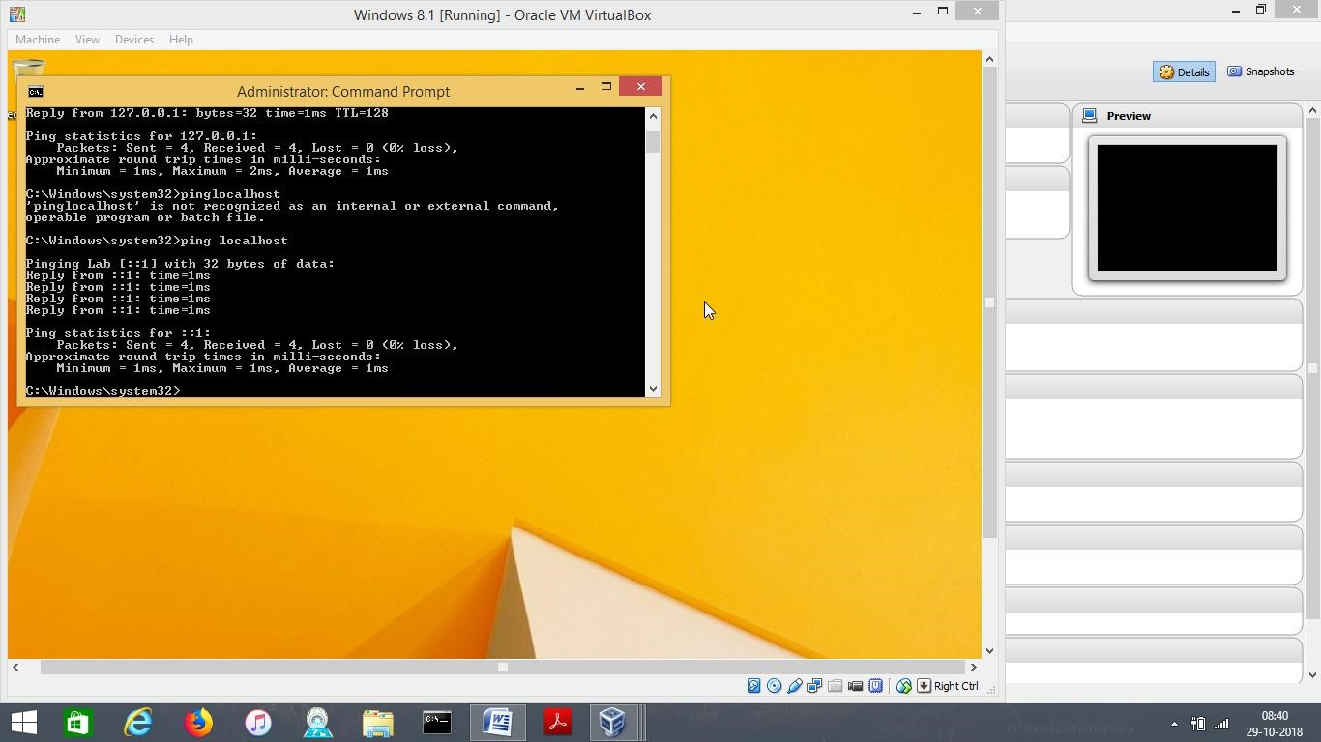

**Step 3: View and Modify the Host File.**

-On Windows 8.1, go to run and type notepad

c:\windows\system32\drivers\etc\hosts and a hosts file opens

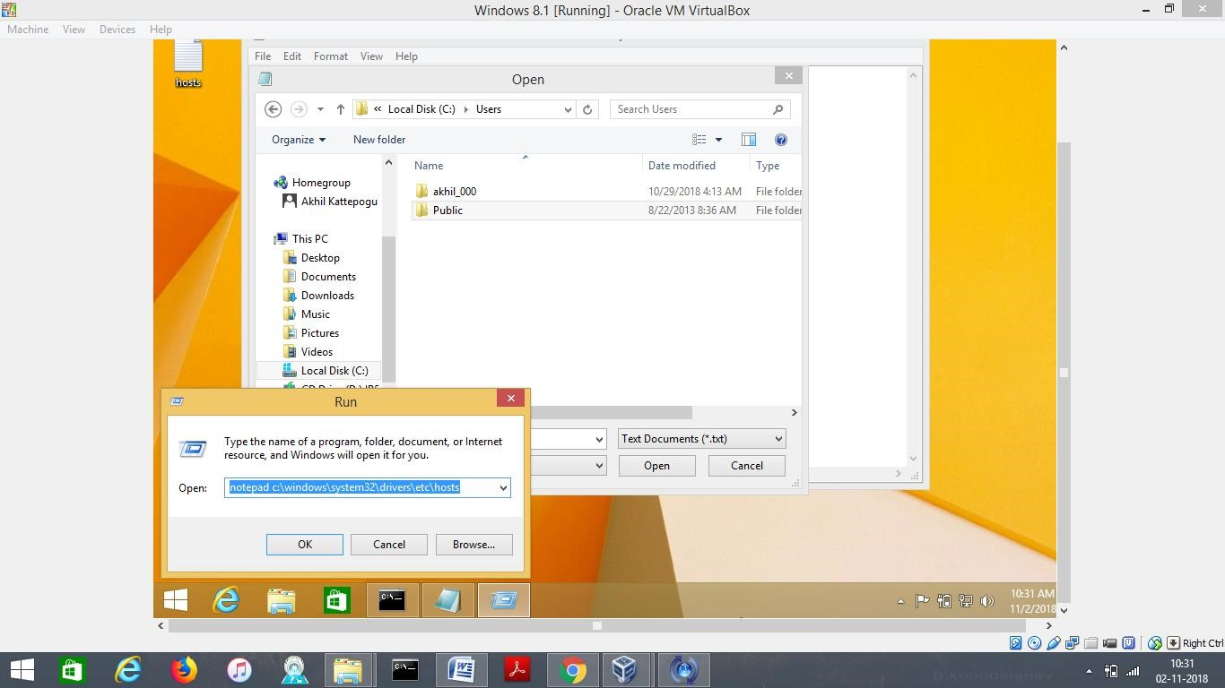

-Add ip address as shown below to the hosts file and save the changes.

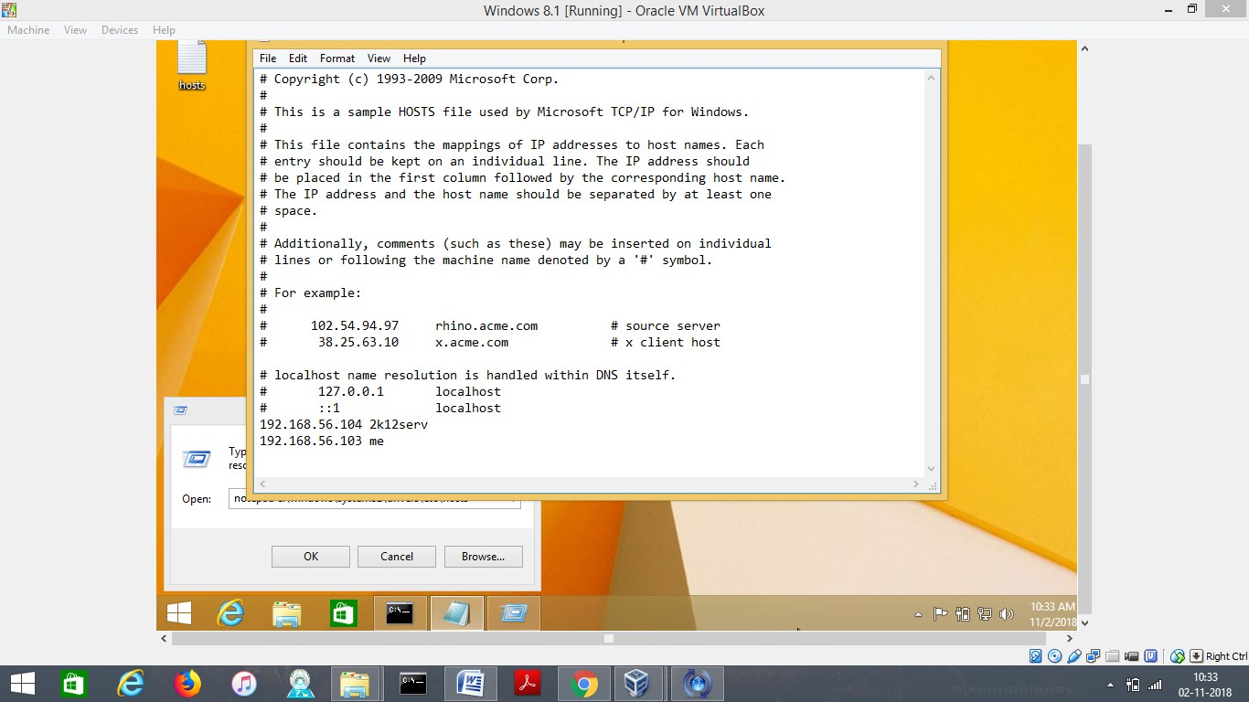

-Type ping me on command prompt

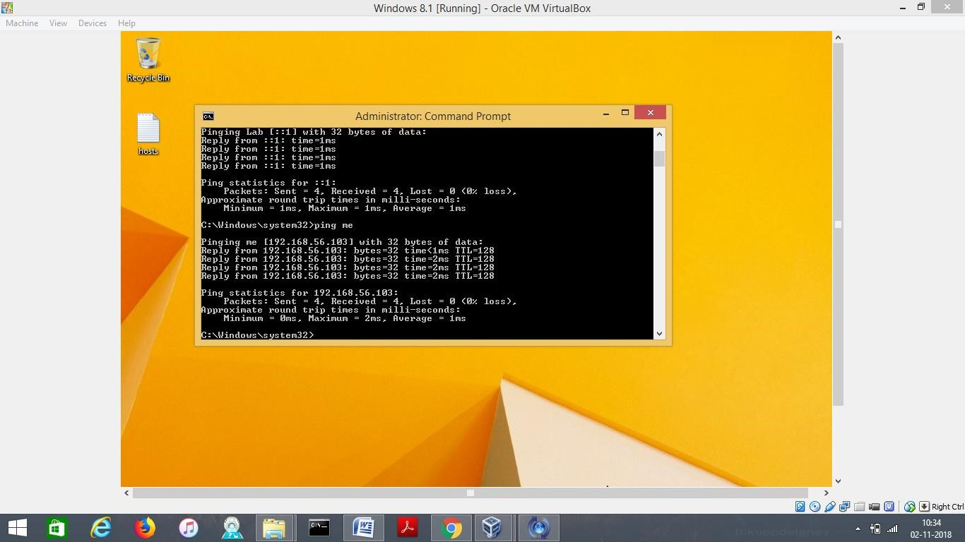

-Type ping 2k12serv on CMD and we can see the reply from the server.

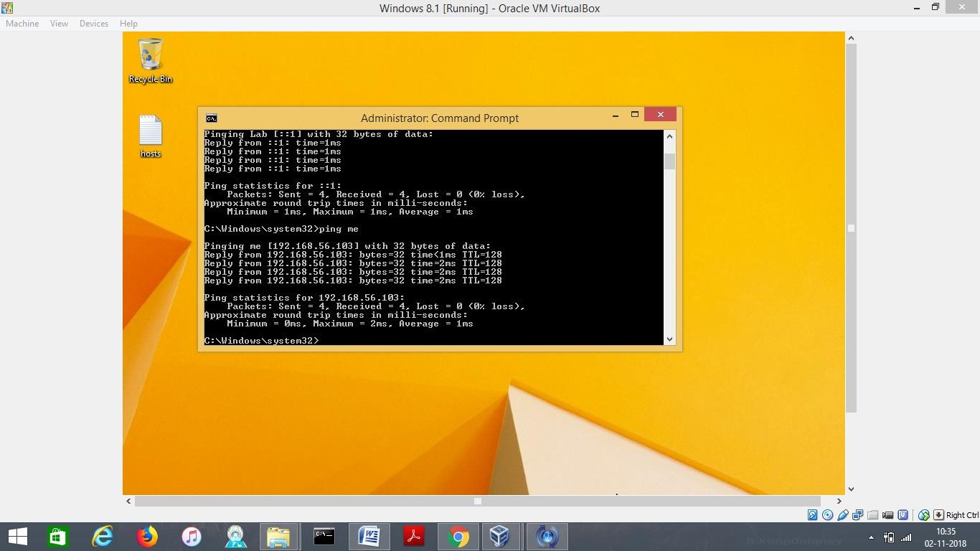

-Type ipcofig /displaydns

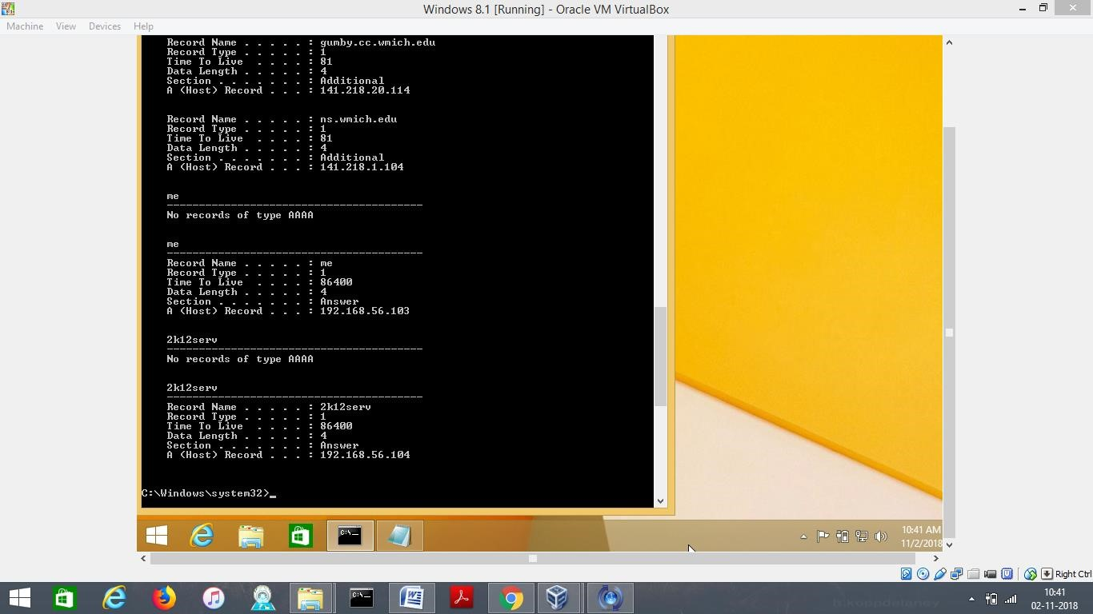

# 4 Lab 1.3w: Windows IPv6 Basics

**Step 1: Verify IPv6 Setting for Win8.1 and W2K12.**

-Type netsh interface ipv6 show address, on command prompt on Windows8.1

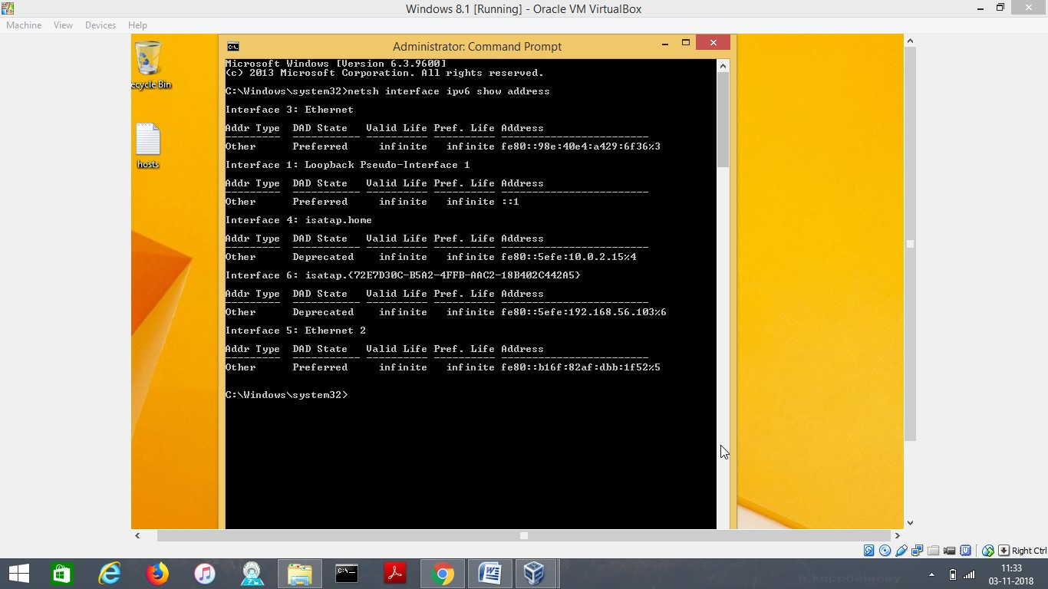

On W2k12, type netsh interface ipv6 show address on command prompt.

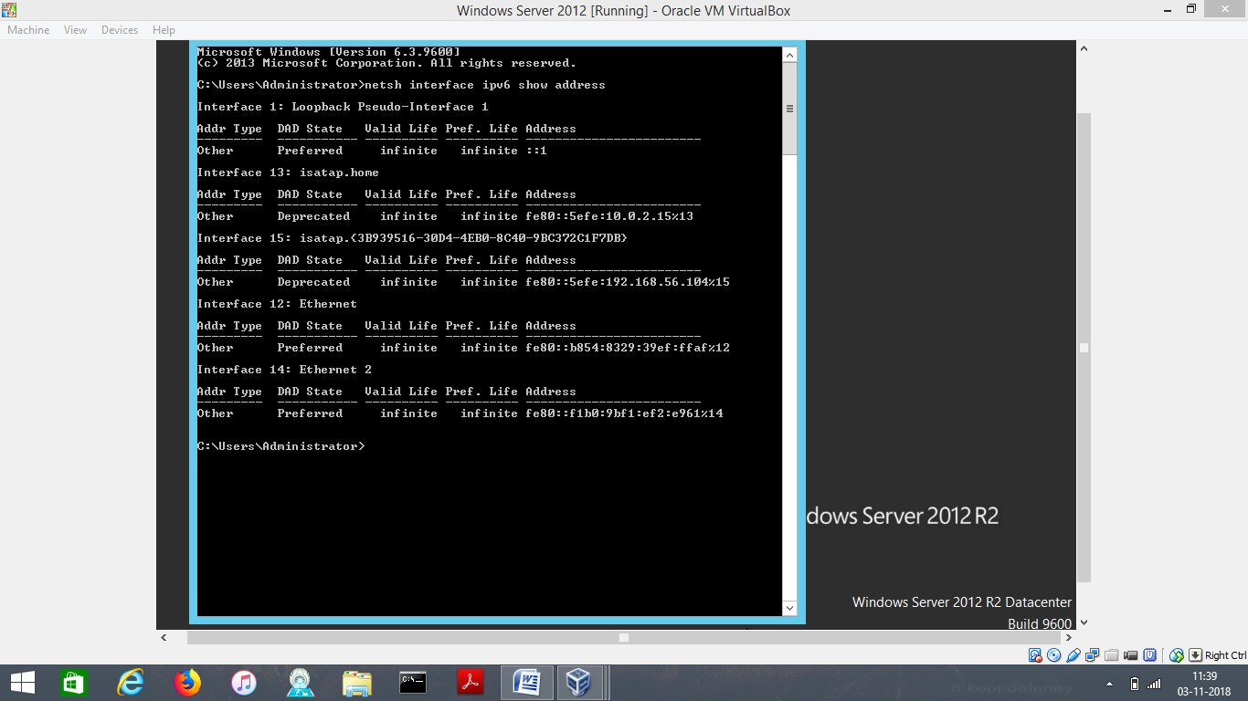

**Step 2: Install Wireshark on Win8.1.**

-From website [www.wireshark.org/download.html](http://www.wireshark.org/download.html) , download wireshark.

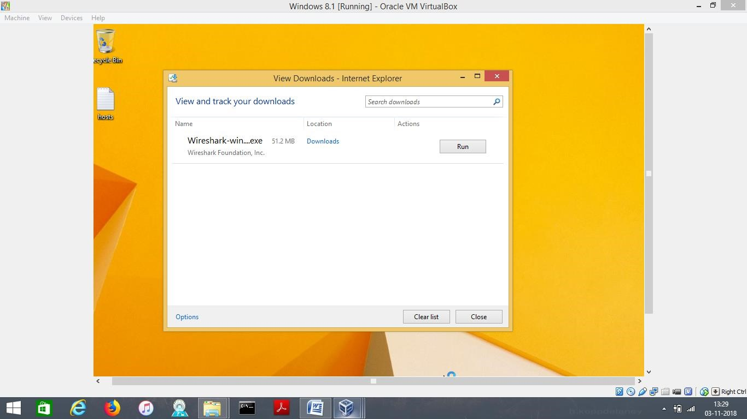

-Follow the steps and install wireshark.

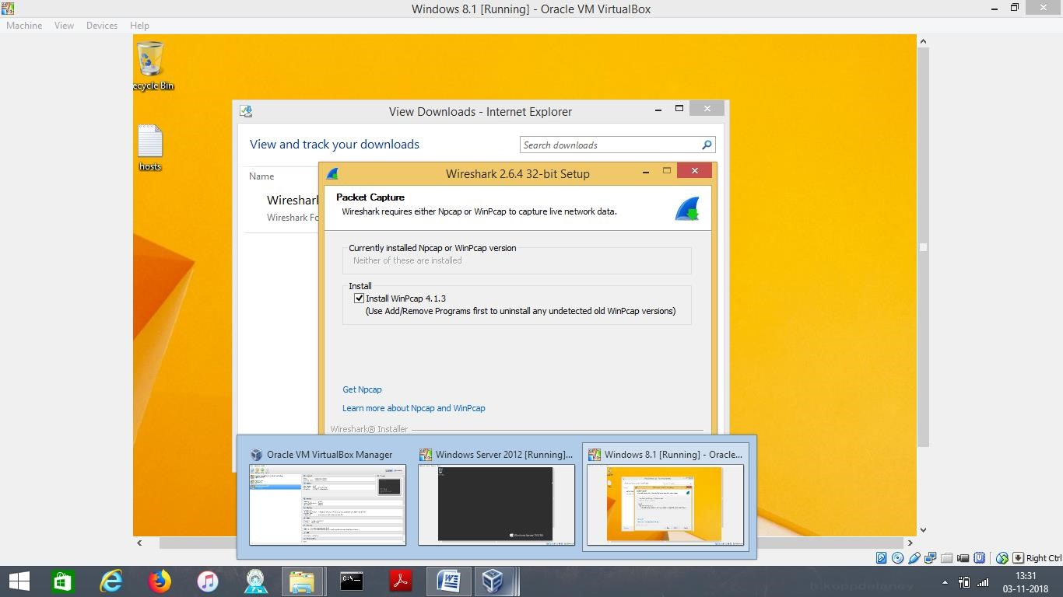

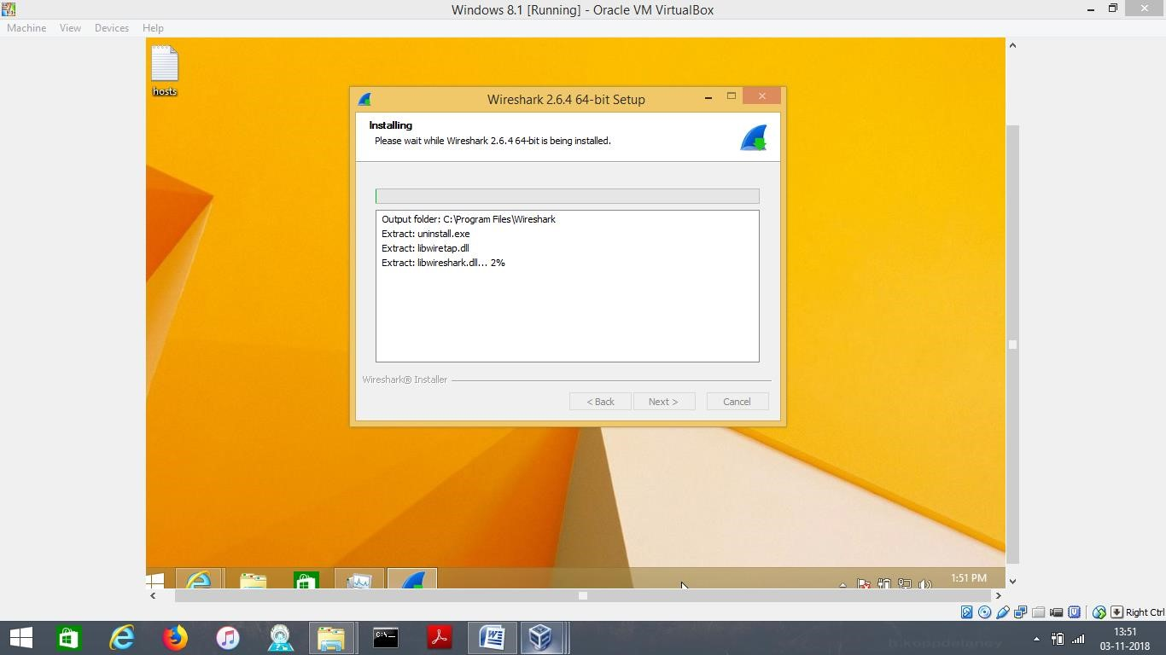

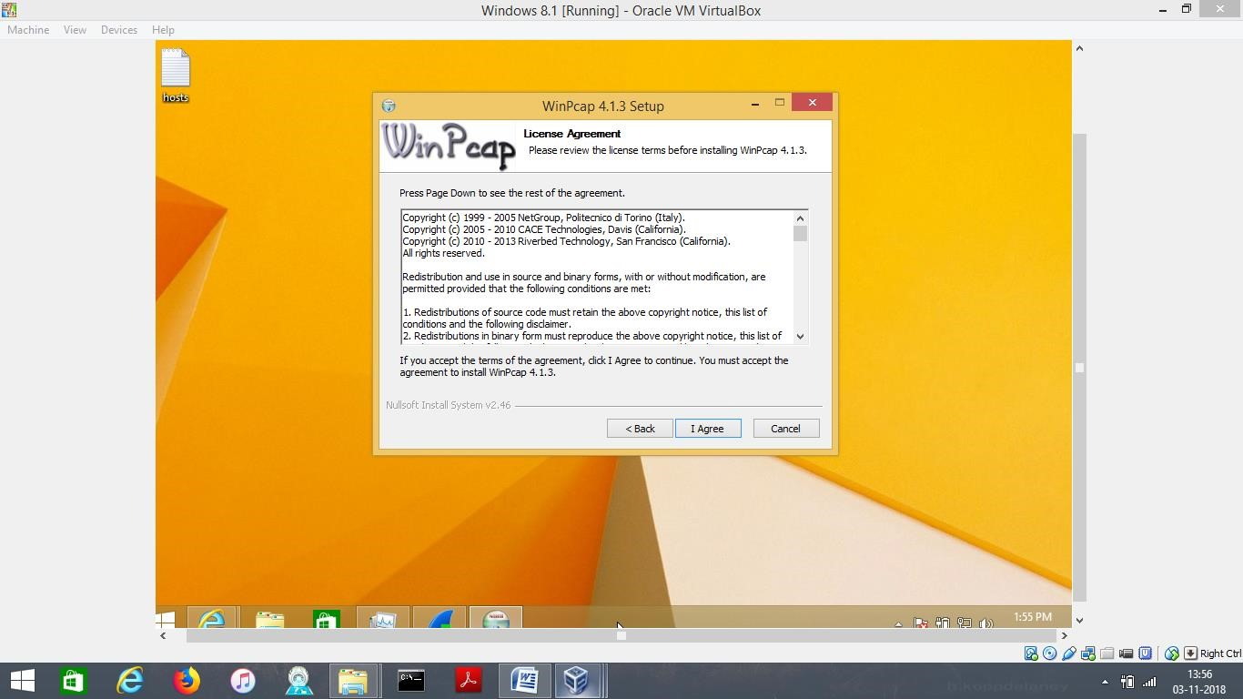

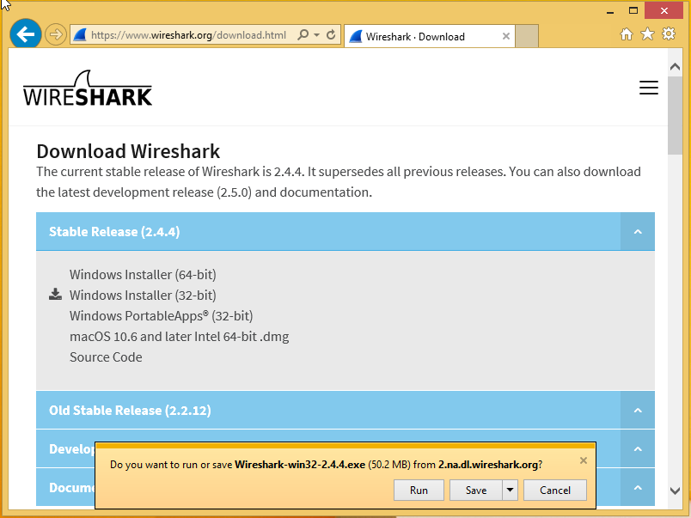

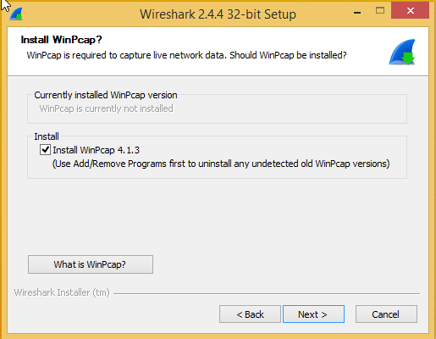

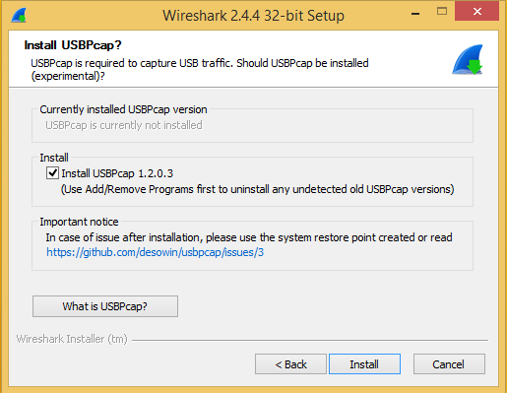

OPENING WIRESHARK 10:17 PM

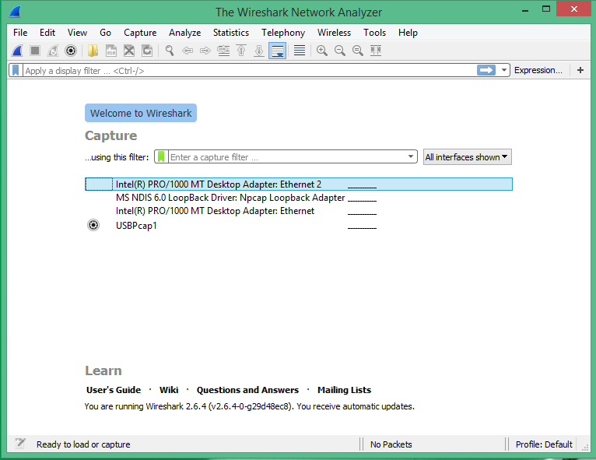

STARTING CONFIGURATION 10:31 PM

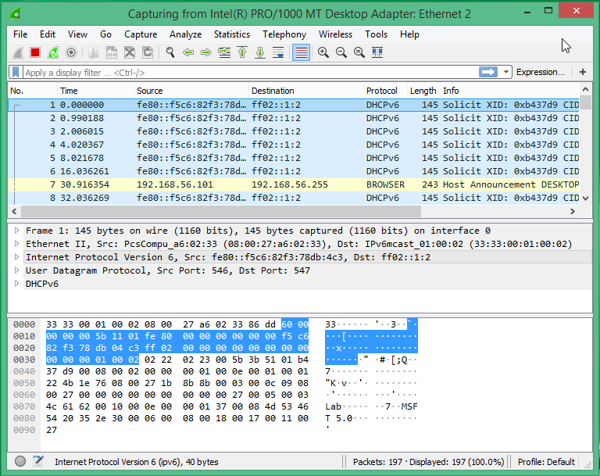

PING -6 COMMAND 10:39 PM

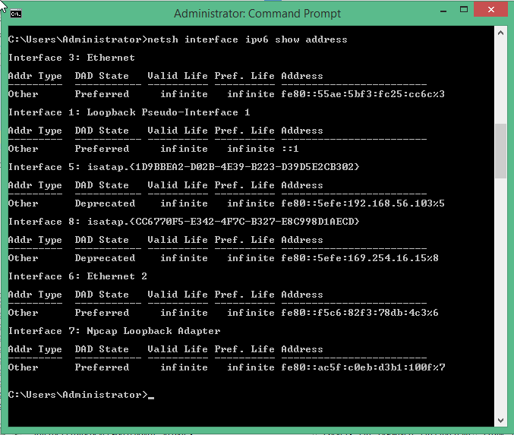

SESSION CAPTURED IN WIRESHARK 10:46 PM

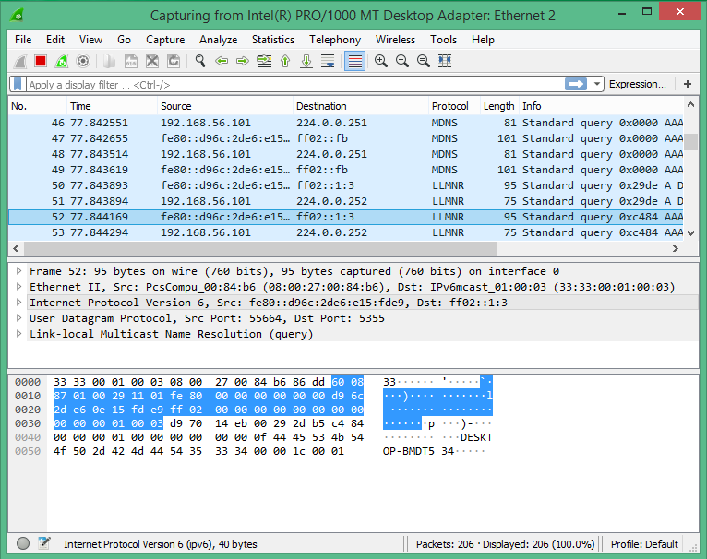

CLEARING THE ARP CASH,TYPE ARP-A 10:51 PM

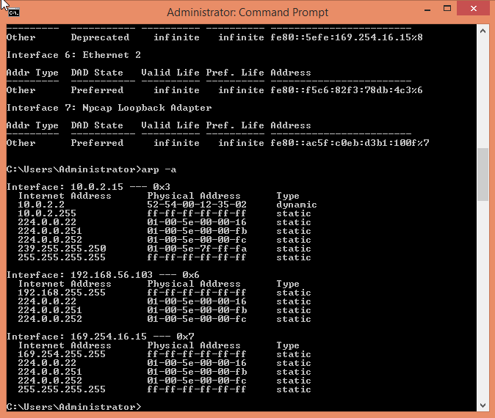

TYPING ARP-P AND ARP-A AGAIN IN COMMAND PROMPT 10:59 PM



START CAPTURING WIRESHARK SESSION 11:00PM

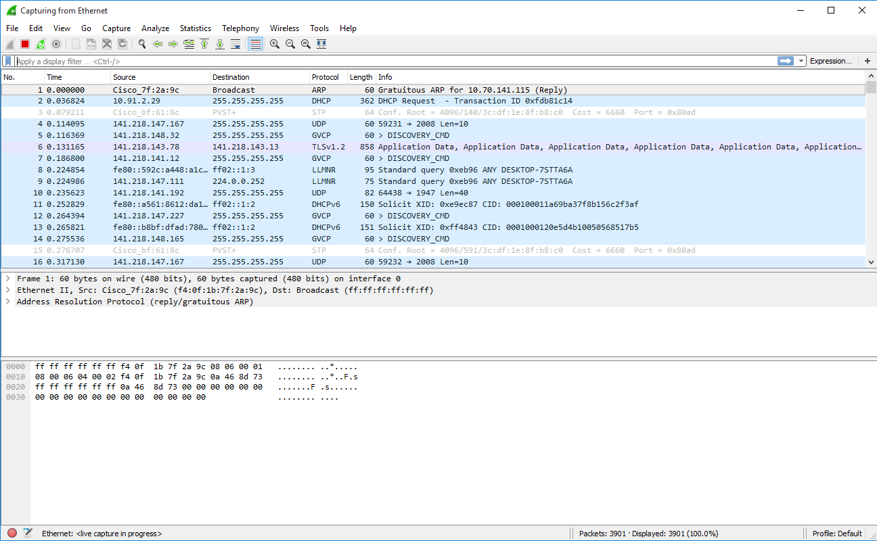

STOP CAPTURING SESSION 11:01 PM

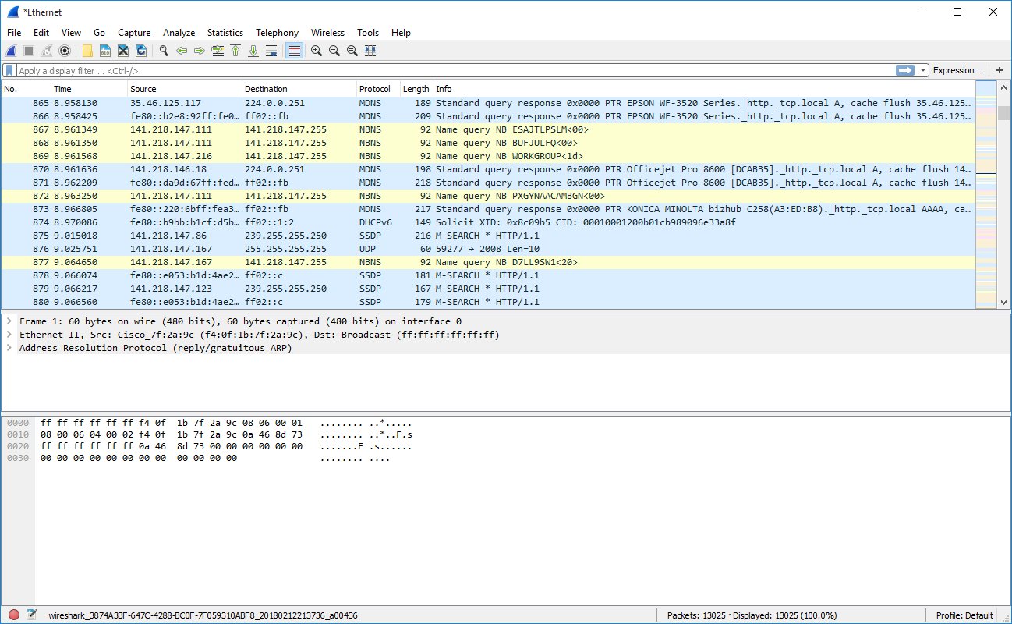

SESSION



PORT CONNECTION STATUS 011: 14 PM

TYPE NETSTAT IN COMMAND PROMPT

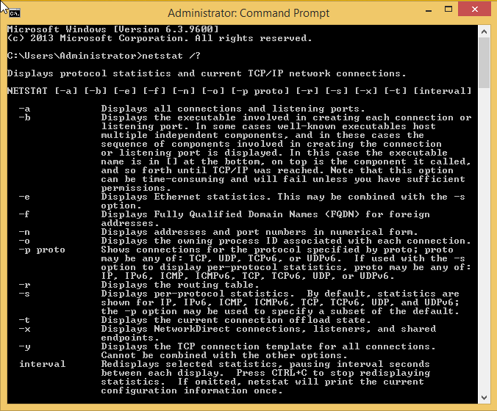

TYPE NETSTAT-A 06:21 PM

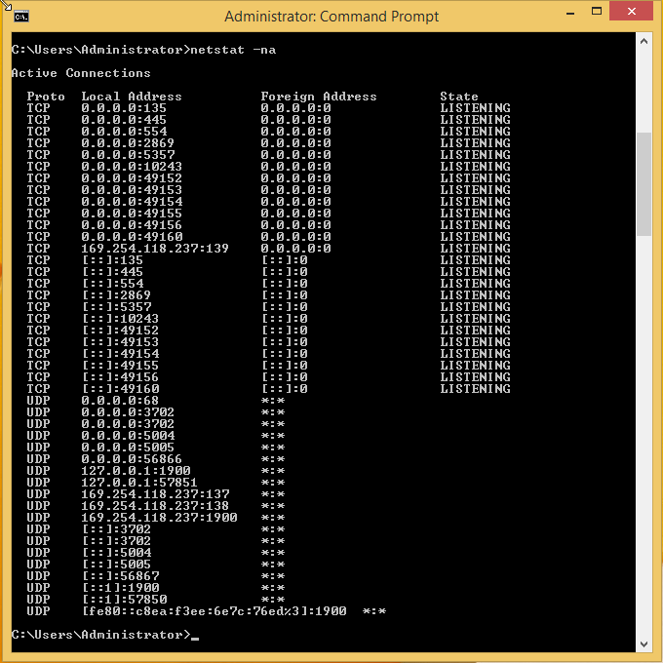

I THINK YOU ARE ASKED TO DO HERE.SO ,IT IS DONE TILL HERE

Best Sampath Talluri.